Google Cloud

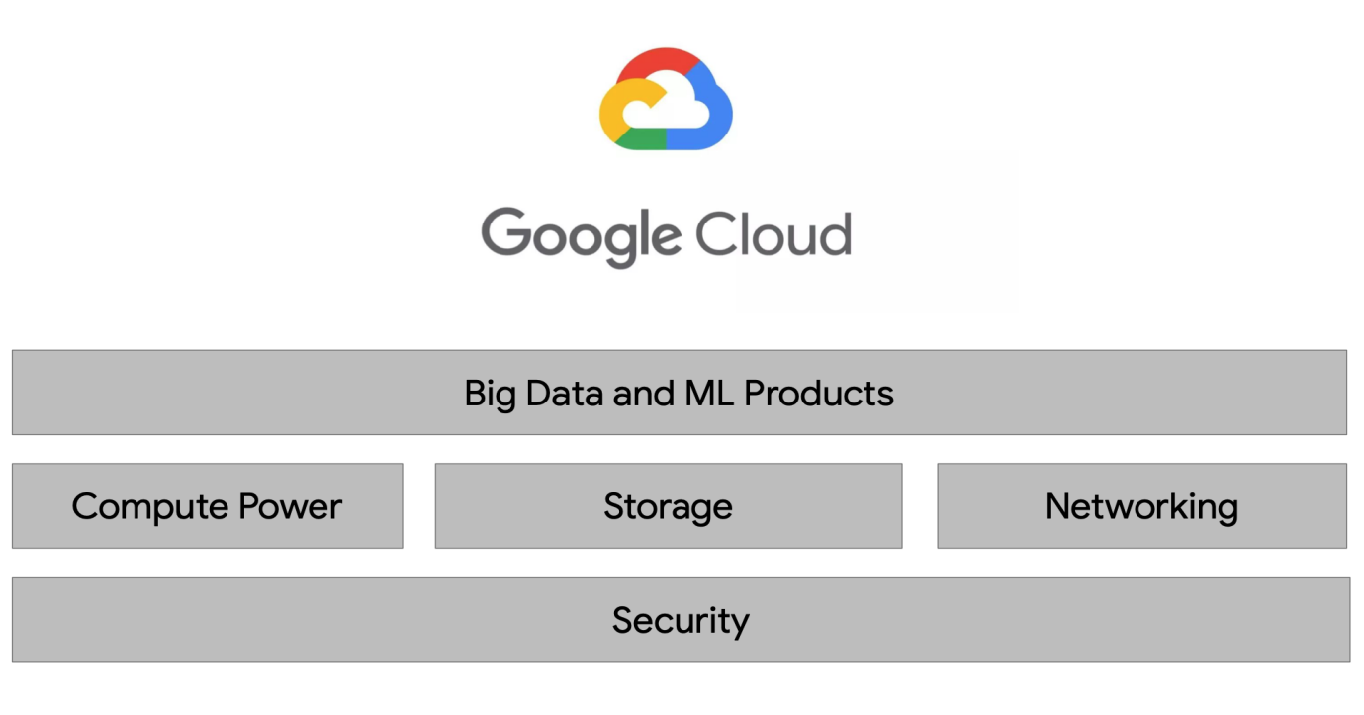

There are four fundamental aspects of Google’s core infrastructure and a top layer of products and services that you’ll interact with most often.

1. **Security (Base Layer)**  
   The base layer that covers all of Google’s application is security.
2. **Compute, Storage and Networking**  
   On top of that are compute, storage, and networking. These allow you to process, store, and deliver those business-changing insights, data pipelines, and ML models.
3. **Big Data and ML Products**  
   Finally running your Big Data applications on bare metal virtual machines is possible, Google has developed the top layer of big data and ML products to abstract away a lot of the hard work and managing and scaling the infrastructure for you.

A growing data organization like yours will need lots of compute power to run big data jobs -- especially as you design for the future to outpace your growth in new users and data for the next decade.

# Google Storage

There are four storage classes for you to choose from based on your data needs.

* Standard Storage
* Nearline Storage
* Coldline Storage, and
* Archive Storage
* Regardless of which one you choose, all classes have multi-region, dual-region, and region location options.
* Bucket names have to be globally unique and GCP assigns a project id that is globally unique too.

# GCP Resource Hierarchy

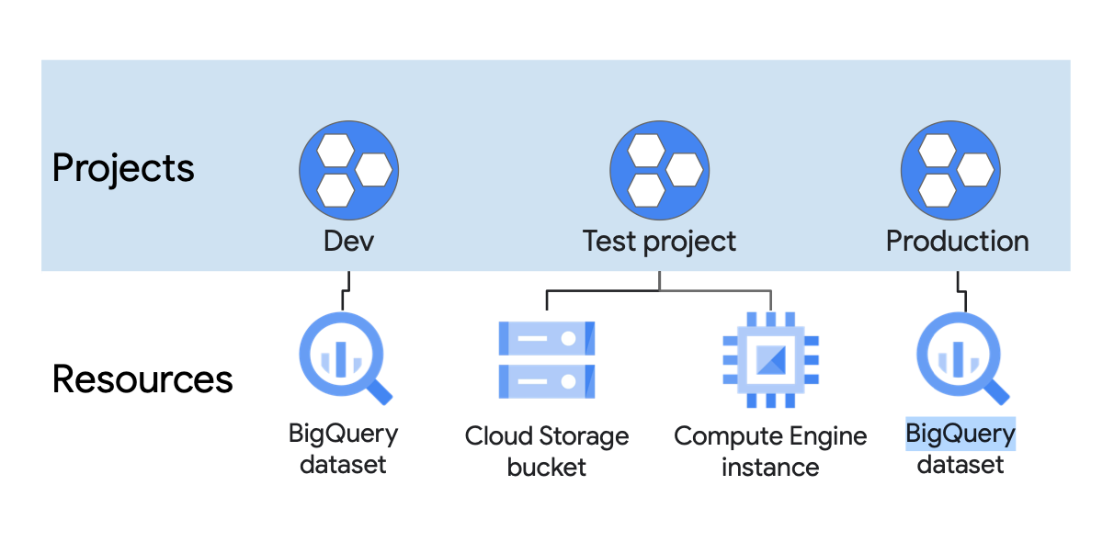

## **Project**

A project is the base level organising entity for creating and using resources and services and managing billing, API’s and permissions.

Zones and regions physically organise the GCP resources you use, projects and logically organise them. Projects can be easily created, managed, deleted or even recovered from accidental deletion.

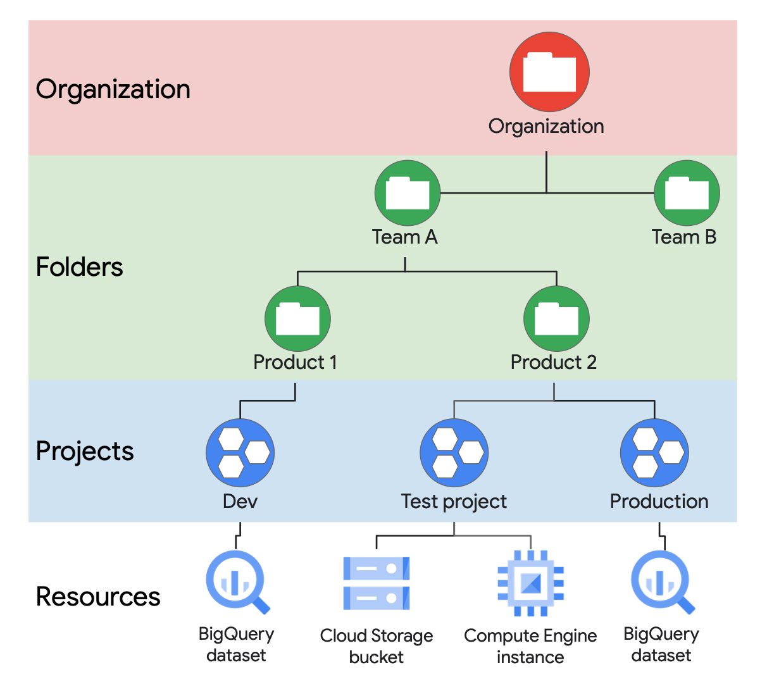

**Folders** are another logical grouping you can have for collections of projects. Having an organisation is required to use folders, and the organisation is the root node of the entire GCP hierarchy.

Lastly, while not required, an organisation is quite useful because it will allow you set policies that apply throughout the enterprise.

# Google Compute Engine (GCE)

## [Compute](https://cloud.google.com/compute/)

* Zonal
* Fast booting Virtual Machine (VMs) you can rent, on demand
* Infrastructure-as-a-Service (IaaS)
* Machine Type
  + Standard
  + High Memory
  + High CPU
  + Custom CPU/RAM
* Pay by the seconds (60 seconds min) for CPU’s, RAM
* Automatically cheaper if you keep running it (“sustained use discount”)
* Even cheaper for preemptible or long-term use commitment in a region.

## [Google Kubernetes Engine](https://cloud.google.com/kubernetes-engine/)

* Regional
* Managed Kubernetes cluster for running Docker containers (with autoscaling).
* Used to be “Google Container Engine” but still GKE until Nov 2017.
* Kubernetes DNS on by default for service discovery.
* No IAM integration.
* Integrates with Persistent disk automatically.
* Pay for underlying GCE instances
  + Production cluster should have 3+ nodes.

## [Google App Engine](https://cloud.google.com/appengine/)

* Regional
* Platform as a Service (PaaS) that takes your code and runs it.
* Much more than just compute – Integrates storage, queues, NoSQL etc.
* Flex mode (“App Engine Flex”) can run any container and access VPC.
* Auto scales based on load even scale to zero if no load

## [Google Cloud Functions (GCF)](https://cloud.google.com/functions/)

* Runs code in response to events.
* Function as a Service (FaaS), “Serverless” – Similar to AWS Lamda
* Pay for CPU and RAM assigned to function, per 100 ms (min 100ms)
* Each function automatically gets an HTTP endpoint.
* Can be triggered by GCS objects, Pub/Sub messages etc.
* Massively scalable (horizontally) – runs many copies when needed.
* Often used for chatbots, message processors, IoT, automations etc.

# Storage

## [Local SSD](https://cloud.google.com/compute/docs/disks/" \l "localssds)

* Zonal
* Very fast 375GB solid state drives physically attached to server.
* Can stripe across eight of them (3TB) for even better performance.
* DATA WILL BE LOST whenever the instances shut down.
  + But can survive a long migration.
* Always encrypted at rest.

## [Persistent disk](https://cloud.google.com/persistent-disk/) (PD) – Amazon EBS

* Flexible block-based network -attached storage; boot disk for every GCS instance.
* Performance scales with volume size; max way below Local SSD, but still plenty fast.
* Persistent disk persists and are replicated (zone or region) for durability.
* Can resize while in use (upto 64 TB), but need file system update within VM.
* Snapshots adds more flexibility and capability.
* Not file -based NAS, but can mount to multiple instances if all are read-only.

## [Cloud Firestore](https://cloud.google.com/filestore/) – Amazon EFS

* Fully managed file-based storage.
* Accessible to GCE and GKE through private VPC, via NFSv3 protocol.
* Primary use case is application migration to GCP
* Fully manages file serving, but not backups.
* Pay for provisions TB’s slow or premium.

## [Google Cloud Storage GCS](https://cloud.google.com/storage/) – Amazon S3

* Regional or Multi-regional.
* Infinitely scalable, fully managed, versioned, and highly-durable object storage.
* Designed for 99.99999999999 (eleven 9’s) durability.
* Strongly consistent.
* Integrated site hosting and CDN functionality.
* Lifecycle transitions across classes:
  + Multi-regional
  + Regional
  + Nearline
  + Coldline
* All classes have same API, so you can use gsutil

# DATABASES

## Cloud SQL – Amazon RDS

* Regional
* Fully managed and reliable MySQL and PostgreSQL databases.
* Supports automatic backup, replication and failure etc.
* Scaling is manual both vertical and horizontal
* Effectively pay for underlying GCE instances and PD’s.

## Cloud Spanner

* Regional, multi-regional or global.
* The first horizontal scalable, strongly consistent, relational database service.
* Chooses consistency and Partition-tolerance (CP of CAP Theorem)
* But still high availability, SLA is 99.999% and SLO is 99.99999%
* Pay for provisioned node time plus used storage-time. Very highly expensive

## BIG Query (BQ)

* Multi-regional
* Serverless common-store data warehouse for analytics using SQL.
* Scales internally (TB in seconds and PB in minutes)
* Pay for GB’s actually scanned during queries.
* Attempted to reuse cached results which is free.
* Pay for data stored GB’s/month
* Pay for streaming data

## BIG TABLE

* Zonal
* Low latency and high throughput NoSQL DB for large operational and analytics app.
* Supports open source HBase API.
* Integrates with Hadoop, Dataflow and Dataproc.
* Scales seamlessly and unlimited.
  + Storage autoscales
  + Processing nodes needs to be scaled manually.
* Pay for processing node hours and GB-hours for storage

## Cloud Datastore

* Regional and multi-regional.
* Managed and auto scaled NoSQL DB with indexes, queries and ACID trans support.
* Queries are complicated due to NoSQL
  + No joins or aggregates must line up with indexes.
  + NOT, OR, and NOT EQUALS (<>, !=) operations not natively supported
* Automatic built-in indexing for simple filtering and sorting.
* Manual composite indexes for more complicated, but beware them exploding.

## Firebase Realtime DB & Cloud Firestore

* No SQL document stores with ~real time client updates via managed websockets.
* Firebase DB is single JSON doc located in central US.

# DATA TRANSFERS

## DATA Transfer Appliance

* Rackable, high capacity storage server to physically ship data to GCS.
* Ingest only.
* 100 TB or 480 TB versions.

## Storage Transfer Service

* Destination is always GCS bucket.
* Source can be S3, HTTP/HTTPs endpoint.
* One time or scheduling transfers.
* Free to use, but pay for its action.

# External Networking

<Details pending>

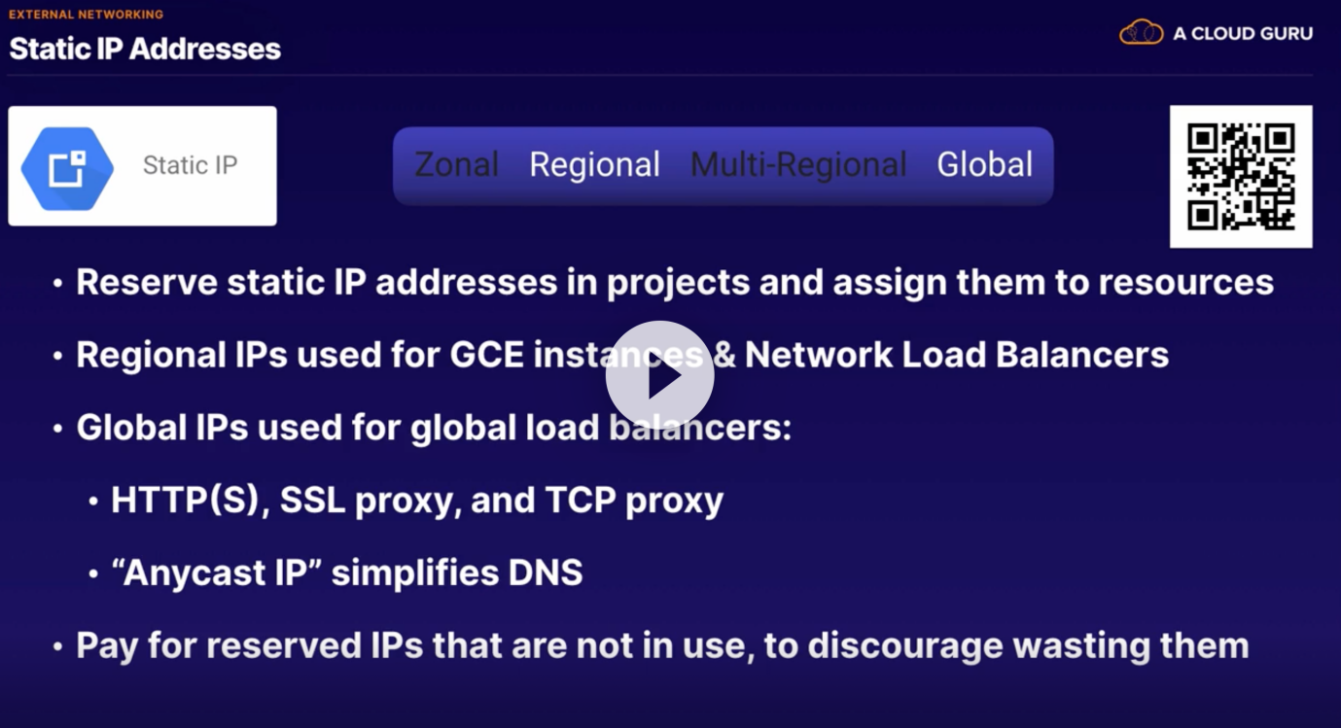

# INTERNAL NETWORKING

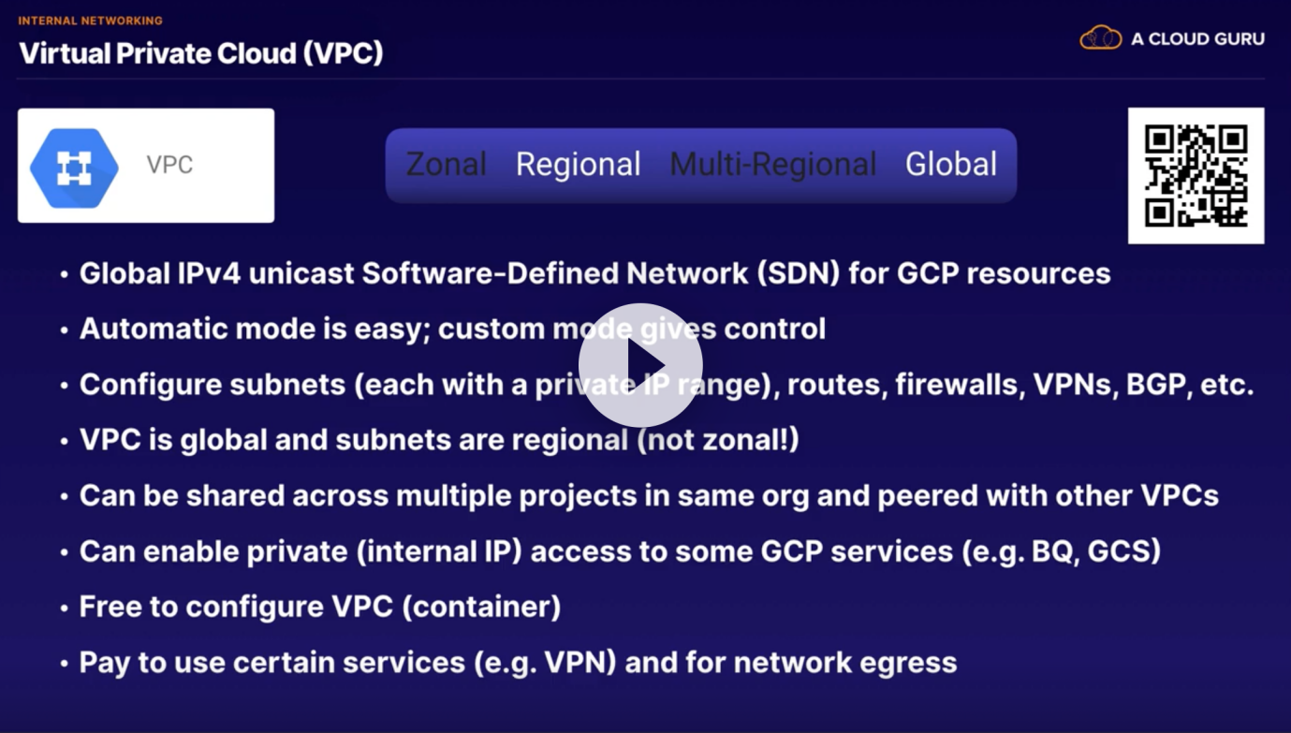

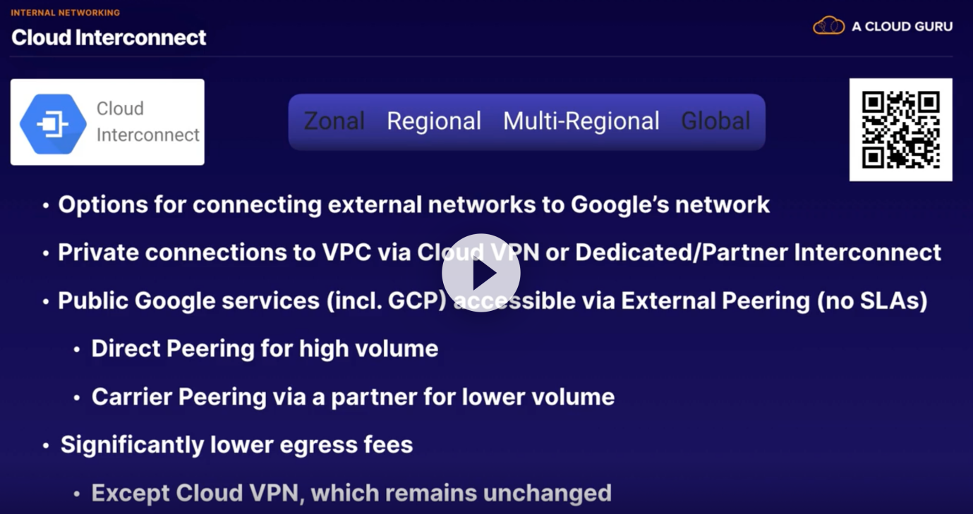

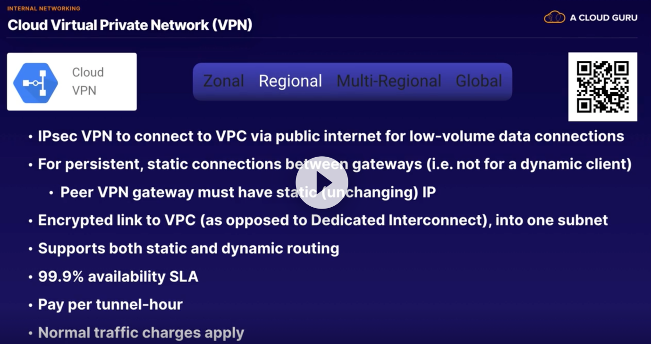

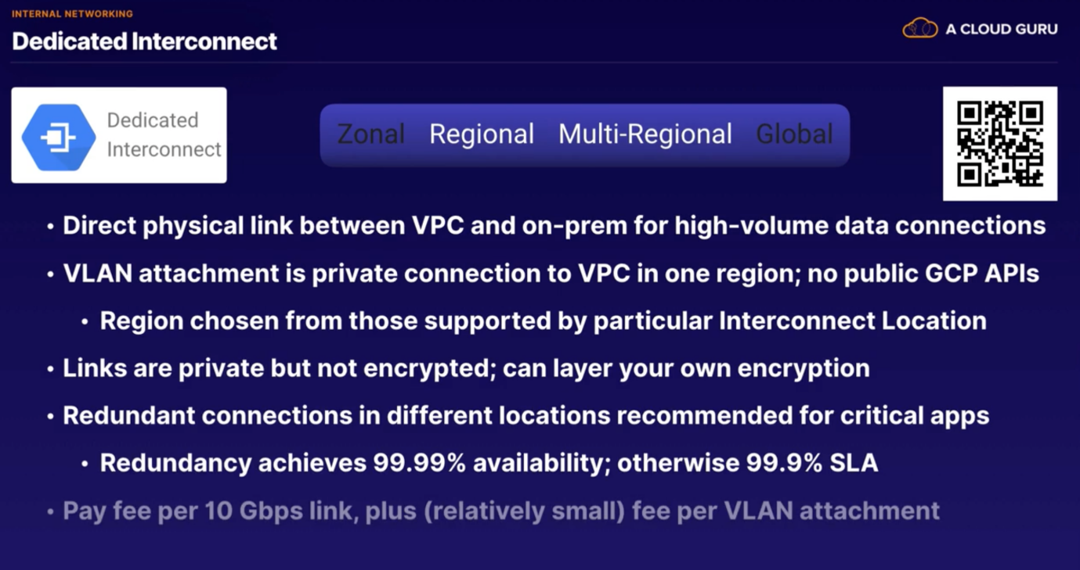

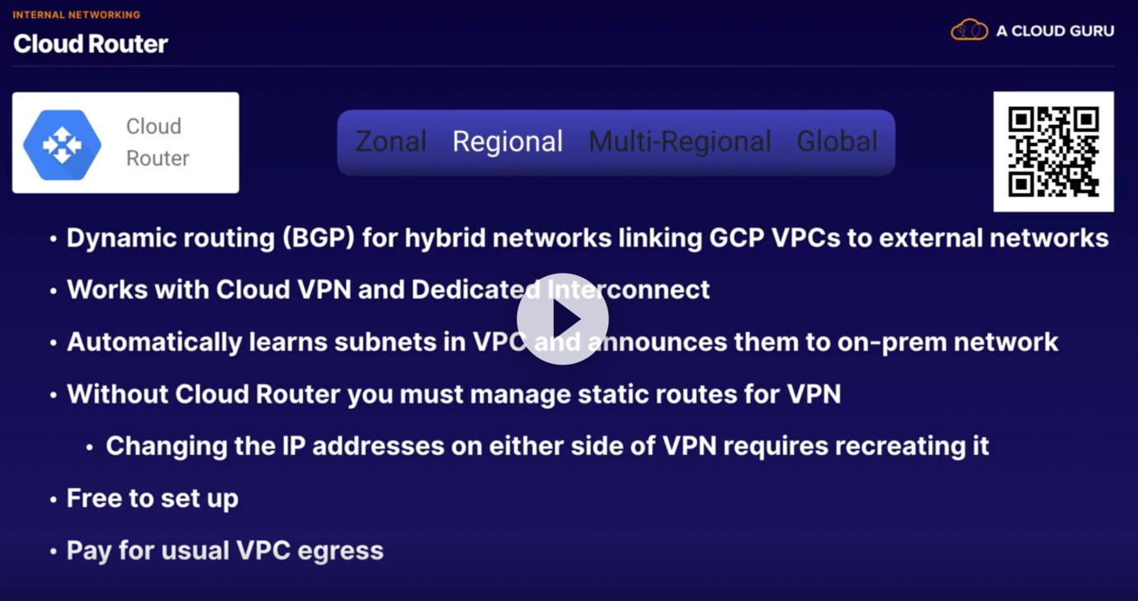

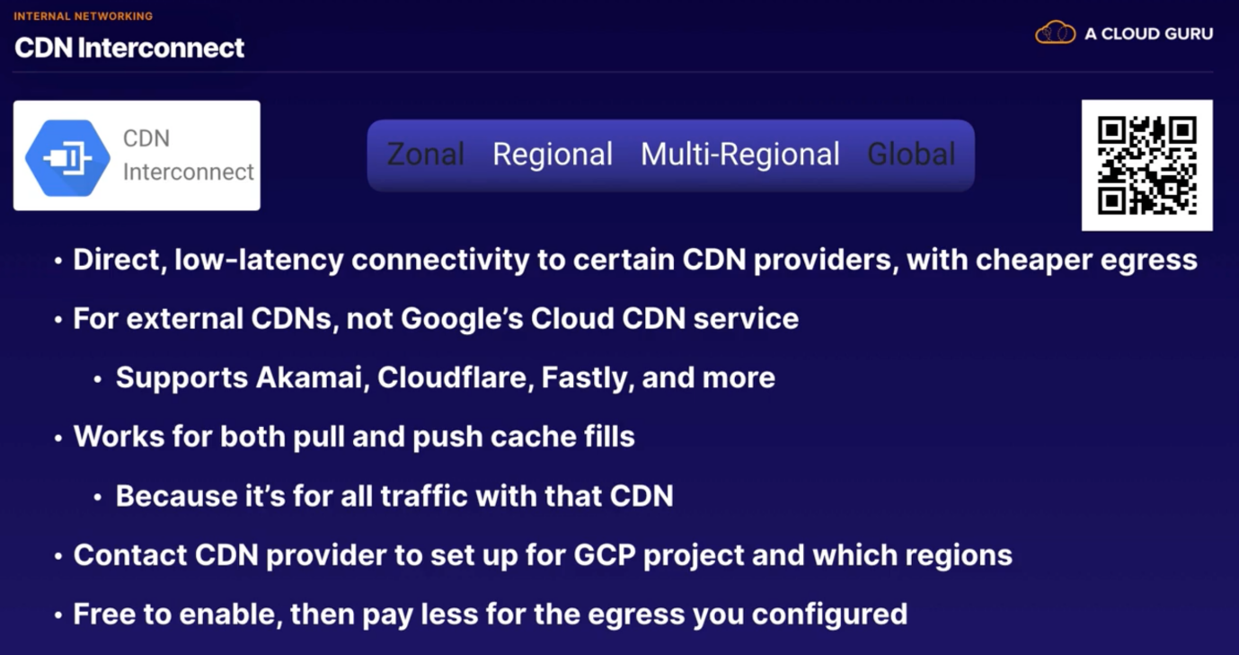

# MAchine Learning and AI

